Enhancing Heart Disease Prediction through Optimized Ensemble Machine Learning Models: A Hyperparameter Tuning Approach

Name  
*Department of Mathematics*  
*Chandigarh University*Mohali, Punjab  
email@gmail.com

Name  
*Department of Mathematics*  
*Chandigarh University*Mohali, Punjab  
email@gmail.com

*Abstract*—heart disease and other cardiovascular illnesses are among the important sources of death. Early diagnosis and precise estimation of cardiovascular risk factors are essential for prompt intervention and prevention. To train and evaluate them, this work uses a variety of techniques and approaches, including KNN, random forests, and SVM. A comprehensive dataset with a broad variety of demographics, clinical, and lifestyle characteristics is used to achieve this goal. The study aims to enhance cardiovascular risk prediction accuracy and help physicians predict diseases early, allowing for appropriate treatment. To improve the efficiency and interpretability of the model, researchers are investigating methods for feature selection. The objective is to enhance overall prediction accuracy and handle any data difficulties to strengthen the predictive models' resilience. The study paper's conclusions reveal a 90% accuracy rate, which complements current initiatives to improve cardiovascular risk assessment through the use of sophisticated analytics. These findings will ultimately support preventative measures and individualized treatment plans. Additionally, the study's models can be used by clinicians and healthcare professionals to predict ailment at an initial phase that allows for appropriate treatment.

Keywords—Heart Illness, Risk Assessment, Prediction, Sophisticated Analytics, Treatment.

# Introduction

Vascular diseases are a foremost source of deaths in various populations, making them a daunting global health concern. Heart illness is single of the numerous CVDs that still has a significant impact on both patients and healthcare systems. The timely implementation of treatments and preventative strategies against heart disease is contingent upon the early diagnosis and precise forecasts for heart disease risk factors. Sophisticated statistical analysis as well as machine learning (ML) are becoming powerful tools for controlling and forecasting chronic illnesses at the nexus of healthcare and technology [1]. These findings will ultimately support preventative measures and individualized treatment plans. To carefully customize feature subsets to a chosen algorithm, future research might investigate various combinations of machine learning algorithms and feature selection techniques. Furthermore, physicians and other healthcare workers might utilize the study's models to anticipate illnesses in their early stages, allowing for appropriate treatment. Machine learning techniques offer a chance to improve prediction accuracy and personalize risk classification, even though conventional risk assessment methods have advanced significantly. To make well-informed judgments on the use of each algorithm in clinical practice, this thorough review attempts to highlight each algorithm’s rewards and weaknesses [2]. Using a diversity of machine learning approaches, the chief objective is to significant contribution to this changing field by delving deeply into the modeling and prediction of cardiac disease. The study's findings can be used to enhance cardiovascular risk prediction accuracy and help physicians predict ailment at an initial phase that allows for correct handling. It has been demonstrated that these ML algorithms are better at making predictions from large amounts of data [3]. Additionally, they can represent more intricate correlations between predictors and outcomes, which are often more difficult to explain using conventional statistical techniques.

Heart disease, encompassing a spectrum of cardiovascular diseases (CVDs) affecting the circulatory system and coronary arteries, remains the predominant cause of global mortality and morbidity [4]. Conferring to the WHO, outrageously the year 2019 witnessed 17.9 million deaths worldwide attributed to cardiovascular ailments, representing nearly 32% of all recorded fatalities.

While conventional peril aspects and different habits have traditionally formed the bedrock of heart disease risk assessment, there is a growing recognition that integrating advanced computational methods, particularly machine learning (ML) algorithms, holds immense potential to elevate the accuracy and efficiency of predictive modelling [5]. Although these variables remain pivotal, the evolving landscape of healthcare analytics underscores the need for sophisticated ML algorithms to discern intricate patterns within extensive datasets, providing a pathway to more nuanced risk assessments and tailored intervention strategies [6]. Mechanism education is a powerful instrument that can recognize intricate correlations and non-linear interactions between a variety of risk variables, making it a potential path toward creating predictive models. In recent years, the use of ML algorithms in healthcare analytics has increased dramatically, with a particular emphasis on the prediction and prevention of cardiovascular events. Studies have shown that machine learning algorithms can significantly improve the precision and effectiveness of predictive modelling for cardiovascular disease [7]. These mathematical models are capable of modeling more complicated links between predictors and outcomes, which are often more difficult to explain using conventional statistical approaches. They can also uncover complex patterns from big datasets. The models of ML have the latent to significantly lower the worldwide epidemic of illnesses and fatalities by predicting infections at an early stage and enabling proper treatment [8].

Myocardial infarctions, commonly referred to as heart attacks, exhibit diverse types, each manifesting unique symptoms and impacting distinct regions of the heart. Heart attacks are classified into the following main types as shown in figure 1.

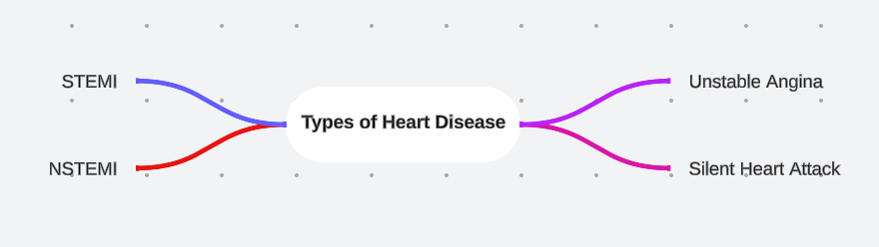

Figure 1 Types of Cardiovascular Disease

STEMI: In this coronary thrombosis vein is blocked which can cause prolonged cessation of blood flow to a segment of the heart muscle . The primary objective in treating STEMI is to minimize heart muscle damage and swiftly restore blood flow, typically achieved through angioplasty or thrombolytic therapy [9].

NSTEMI: Characterized by a partial blockage of a coronary artery, NSTEMI results in reduced blood supply to a section of the heart muscle [10]. While immediate medical intervention is still imperative to prevent further complications, the urgency is generally lower compared to cases of STEMI.

Unstable Angina: Marked by a burning sensation in the chest occurring at rest or with minimal exertion, unstable angina is often considered a warning sign of an impending heart attack. Prompt medical attention is required to prevent the situation from worsening.

Silent Heart Attack: Describing an "invisible" heart attack with minimal or no outward signs or symptoms, individuals may remain unaware of having experienced a heart attack until cardiac damage is revealed through diagnostic procedures like echocardiograms or blood tests [11]. Even silent heart attacks, detectable through routine medical examinations, can lead to consequences.

To improve the precision and effectiveness of prediction models, our study focuses on the predictive modeling of cardiovascular sickness using many approaches of machine learning. Given the complexity and variety of vascular sickness, it is essential to use cutting-edge computational techniques. Machine learning algorithms provide an interesting new way to improve our knowledge of cardiovascular risk variables because of their volume to identify involved patterns and correlations within large datasets [12]. The use of algorithms in healthcare analytics has increased dramatically in recent years, with a particular emphasis on the prediction and prevention of cardiovascular events. Studies have shown that machine learning algorithms can significantly improve the precision of predictive models for heart disease. Our main goals are to identify the most efficient algorithms and identify the contextual aspects that affect their performance. Reaching these objectives will require delving into the complexities of these computer algorithms and comprehending how they function in particular situations [13].

Furthermore, there is currently a rare chance to fully utilize deep learning's potential for proactive and customized cardiovascular risk prediction. The combination of digital technology and artificial intelligence is causing a huge revolution in the healthcare sector. Taking advantage of this chance, our goal is to investigate how deep learning might improve cardiovascular health prediction models. This research is primarily motivated by the goal of advancing predictive modeling as a whole. By doing this, we hope to make a significant contribution to the continuing international efforts to lessen the impact of cardiac disease [14]. In keeping with the larger context of healthcare, our study aims to contribute to the development of techniques that will eventually result in more potent approaches to the early identification and reduction of cardiovascular risks worldwide.

Predictive Modeling of Heart Disease using Diverse ML approaches is covered in the study. The scientific research on the use of different algorithms developed using machine learning for making vascular ailment forecasts is reviewed in Section II. Section III includes the detailed framework of the study, including participant selection criteria, data integration and aggregation procedures, and group modeling nuances. Section IV discusses the acquired prediction accuracy and shows the results from various machine-learning techniques. Finally, the main findings of the research are summarized in Section V, which emphasizes the need to use a diverse group of algorithms to improve heart disease prediction.

# Literature Review

Using machine learning techniques, the authors [15] suggested method in this work seeks to increase the prediction accuracy of heart disease by identifying key traits. This research presents a prediction model that use established classification approaches and incorporates several feature combinations. The prediction model employs the hybrid random forest with a linear model (HRFLM), which leads to an improved performance level and an accuracy of 88.7% in the prediction of heart disease.

The goal of authors [16] is to improve the accuracy of cardiac disease prediction by optimization and machine learning methods. Using datasets from the Cleveland and IEEE Data port, six methods were used: random forest, K-nearest neighbor, logistic regression, Naive Bayes, gradient boosting, and AdaBoost classifier. AdaBoost outperformed logistic regression with an accuracy of 90% on the IEEE Data port dataset and logistic regression with the best accuracy of 90.16% on the Cleveland dataset. With the use of all six methods, the soft voting ensemble classifier strategy resulted in even higher accuracy, 93.44% for the Cleveland dataset and 95% for the IEEE Data port dataset.

The authors [17] study finds that the multilayer perceptron with cross-validation performs better than other algorithms in terms of accuracy after comparing the performance of various methods. In order to facilitate early diagnosis and prompt intervention, the research highlights the need of precise cardiac disease prediction. The potential of machine learning approaches to enhance the precision and effectiveness of cardiac disease prediction is emphasized by the authors.

The article emphasizes the necessity for more precise cardiac disease prediction tools as well as the significance of digitization in healthcare organizations. It highlights how important an early diagnosis is to treating the illness and achieving better results. The authors [18] used predictive modelling, one of the machine learning approaches, may be used to assist forecast chronic illnesses, including cardiac ailments. Metrics like accuracy, True Positive Rate (TPR), and Specificity are used to assess the success of the hybrid machine learning method that combines data from DT and Ada Boosting.

Four distinct datasets with pertinent variables for heart disease prediction were employed in the study. When compared to other machine learning approaches, the K-nearest neighbor (KNN) algorithm and logistic regression yield higher prediction accuracy in less time. The authors [19] used algorithms utilized to create the heart disease prediction model were random forest, KNN, logistic regression, and decision tree.

The review seeks to comprehend the intricacy of the field, instruments, and methodologies utilized by researchers in their machine learning-based heart disease prediction. It was discovered that the Naive Bayes technique performed better in heart disease prediction when the forward selection method with two chosen features and the ROs were used. The authors [20] timely diagnosis and early identification of cardiac disease can result in more effective treatment and more reasonably priced medical services for patients.

The authors [21] used machine learning approaches are the mainstay of current work for heart disease prediction, although their accuracy has not increased. Data analytics has been significantly impacted by recent advancements in deep learning techniques. To obtain greater accuracy than conventional machine learning techniques, the proposed study integrates a long short-term memory (LSTM) network with convolutional neural networks (CNN). An 89% accuracy rate in classifying a heart disease dataset as normal or abnormal was obtained using the hybrid CNN and LSTM approach.

To choose the best characteristics for improving the accuracy of heart disease prediction, the suggested method, called GAPSO-RF, combines a hybrid genetic algorithm (GA) and particle swarm optimization (PSO) optimized methodology based on random forest (RF). The authors [22] used GAPSO-RF method outperformed other cutting-edge prediction techniques, achieving high heart disease prediction accuracies of 95.6 and 91.4 on the Cleveland and Stat log datasets, respectively. The efficacy of the GAPSO-RF technique is assessed using four key performance indicators.

This author [23] uses a huge patient data collection that includes demographic data, laboratory test results, and lifestyle variables to create a model for predicting a person's likelihood of acquiring heart disease based on numerous risk factors. The effectiveness of the model will be assessed using common metrics including specificity, sensitivity, and accuracy. This paper ultimate objective is to develop a tool that will enable medical professionals to identify high-risk patients and provide early therapy to stop the progression of heart disease.

The paper focuses on utilizing the patient's past medical history to determine whether they have cardiac disease. Due to the authors [24] used increased risk of serious cardiovascular events in the senior population, age alone should not be used as a reason to avoid taking any medicine, even the strongest ones.

# Methodology

The methodology of the proposed model is given below in Figure 2 in certain steps starting from the problem definition to the model deployment. The hybrid model of KNN, Random Forest, and SVM is proposed using the ensemble approach.

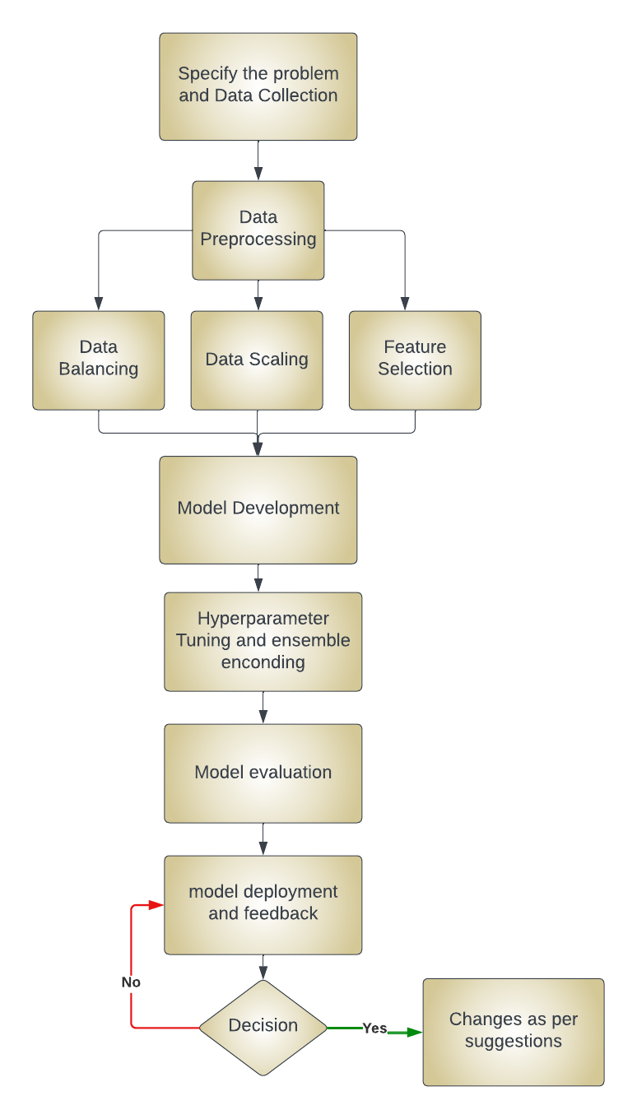

Figure 2 Proposed Material and Methods

## Problem definition and data collection

The process starts with a well-defined problem, which aims to determine the possibility of heart disease in individuals, identifying the types of heart disease and risk factors to be considered. This is followed by data collection, which involves identifying reliable sources such as medical records and public health databases, and selecting relevant features like age, gender, cholesterol levels, and lifestyle factors, while adhering to data privacy regulations.

## Data Preparation and Preprocessing

Data preparation is a crucial step in machine learning that involves several tasks. The first step is data cleaning, which involves identifying and correcting errors, inconsistencies, and missing values in the data. The next step is standardizing the numbers, which involves that make the all value at same level which leads to improve in accuracy. The third step is encoding data that is categorical, which converts categorical data into numerical values, allowing it to be used in machine learning algorithms. The next phase is model selection, which involves selecting relevant machine learning algorithms, such as Random Forest, SVM, and KNN, to build a baseline model for performance comparison. Proper data preparation is essential for accurate insights and informed decision-making.

## Model Training and Validation

Model training is a crucial step in machine learning. This process includes dividing the input information into testing, training, and test sets, applying techniques such as cross-validation with k folds for robust assessment, and tweaking hyperparameters for peak performance. The trained model is then thoroughly evaluated using measures such as reliability, precision, recall, and ROC-AUC. Its efficacy is confirmed and tested on previously unknown data to determine real-world applicability. Proper model training is essential for building accurate and reliable machine learning models, which can be used for various applications, including risk prediction of cardiovascular disease and other medical diagnoses.

## Model Deployment

Deployment is the final phase in which the model is connected to information technology systems for healthcare using a specific platform. This phase involves providing frequent performance monitoring and upgrades. Ethical issues are crucial, addressing any biases and ensuring that the model's judgments are transparent and understandable to healthcare providers. Stakeholders require extensive records and reports that outline the approach, model design, and evaluation outcomes. In simple terms, deployment is the process of integrating the trained model into a healthcare system, ensuring its performance and ethical considerations, and providing detailed records for stakeholders.

## Feedback

Continuous improvement is a crucial approach in machine learning, which involves gathering input from healthcare experts and upgrading the model with fresh data and algorithm developments. This iterative method ensures that the model stays effective and current in the ever-changing sector of healthcare. In simple terms, continuous improvement is the process of regularly updating and refining the model to improve its performance and adapt to new information. This approach helps maintain the model's relevance and accuracy in the rapidly evolving field of healthcare.

# Result and Discussion

Table 1 Evaluation parameters of different ML algorithms

|  |  |  |  |  |  |
| --- | --- | --- | --- | --- | --- |
| Algorithms | Accuracy | Precision | Recall | F1 score | Error |
| Ensemble Model | 0.9 | 0.9 | 0.9 | 0.9 | 0.1 |
| SVM | 0.86 | 0.83 | 0.89 | 0.86 | 0.14 |
| KNN | 0.85 | 0.86 | 0.85 | 0.84 | 0.15 |
| Random  Forest | 0.85 | 0.85 | 0.82 | 0.84 | 0.15 |
| Logistic Regression | 0.85 | 0.83 | 0.86 | 0.84 | 0.15 |
| Gradient  Boosting | 0.78 | 0.76 | 0.79 | 0.77 | 0.22 |
| Decision Tree | 0.75 | 0.69 | 0.86 | 0.76 | 0.25 |

The ensemble strategy combines KNN, Random Forest, and SVM to enhance recall, speed, and accuracy while decreasing errors in predicting cardiac disease. This strategy takes advantage of each algorithm's distinct strengths, aiming for an appropriate and trustworthy tool for predicting cardiac disease, which is especially important given the substantial risks involved in healthcare diagnostics.

## Precision

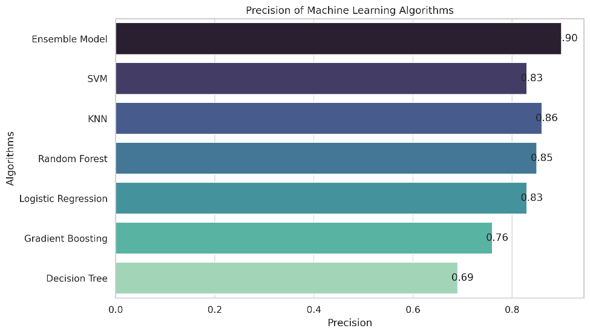

Figure 3 Precision of proposed machine learning model

The precision of a model is really important because it shows how well the model can correctly identify people with heart disease. The ensemble model shows a precision of 0.90. The above figure 3 shows the precision of the different machine learning algorithms. This helps reduce the chances of the model wrongly identifying someone as having heart disease when they don't, which could lead to unnecessary stress or treatment. One way to improve precision is by using a combination of different machine learning methods, like KNN, RandomForest, and SVM. By doing this, the strengths of one method can make up for the weaknesses of another, leading to better overall precision in identifying heart disease cases.

## Recall

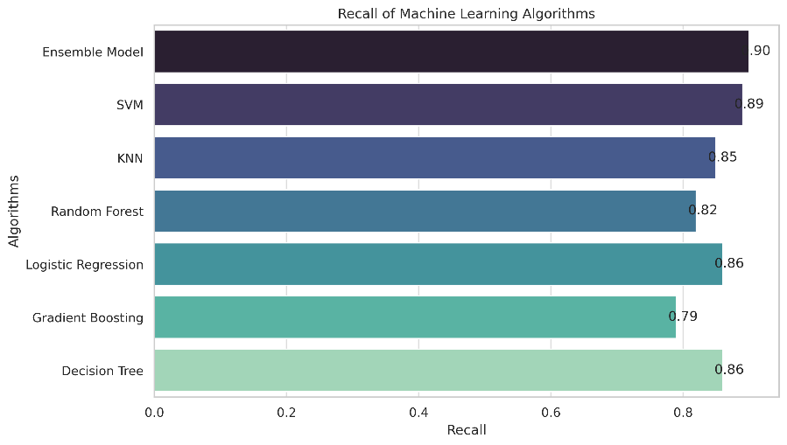

Figure 4 Recall of different machine learning algorithms

The ensemble model tries to improve recall by exploiting the different detection skills of the multiple algorithms, especially if some are better at detecting certain forms of cardiac disease. Several studies have demonstrated the effectiveness of machine learning algorithms, such as random forest, in predicting the risk of cardiovascular disease with high accuracy and specificity. The 0.90 is the sensitivity proposed ensemble model as shown in figure 4. These findings highlight the potential of machine learning in improving the recall of heart disease prediction, ultimately benefiting patient care and outcomes.

## F1 Score

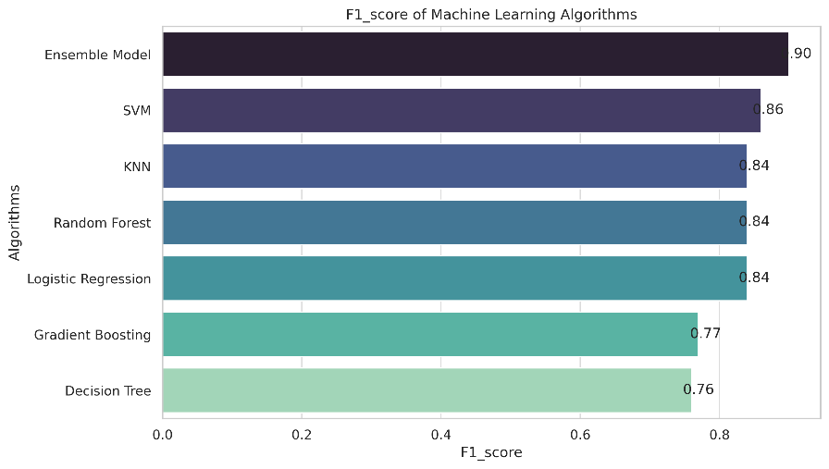

Figure 5 F1 score of various algorithms

In the context of estimating cardiac disease, the F1 score is an important measure. The above figure 5 shows the model validation of f1 score using different algorithms. A high F1 score indicates that the algorithm not only reliably identifies people with heart illness (high precision) but also correctly distinguishes the vast majority of real heart disease cases. The model proposed by the hybrid approach also performs better in the case of the ensemble. This balance is critical in medical contexts, where missing a case of coronary artery disease (poor recall) or misdiagnosing a healthy person (low accuracy) can have catastrophic consequences.

## Error

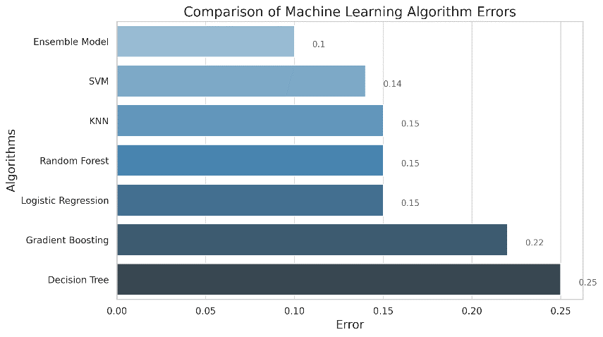

Figure 6 Error of different ML algorithms

The error rate, which represents the fraction of inaccurate predictions, is an important metric in the medical industry. A lower mistake rate is critical to avoiding misdiagnoses, which can result in ineffective therapies or lost early intervention chances. The minimal error obtained in the ensemble hybrid approach is 0.1 as shown in figure 6. The ensemble technique has the potential to minimize overall error rates since the different approaches of KNN, Random Forest algorithm, and SVM may lessen the likelihood of uniform mistakes across the model. In simple terms, the ensemble technique can help improve the accuracy of the model by combining the strengths of different algorithms, reducing the chances of making the same mistake across the model.

## Accuracy

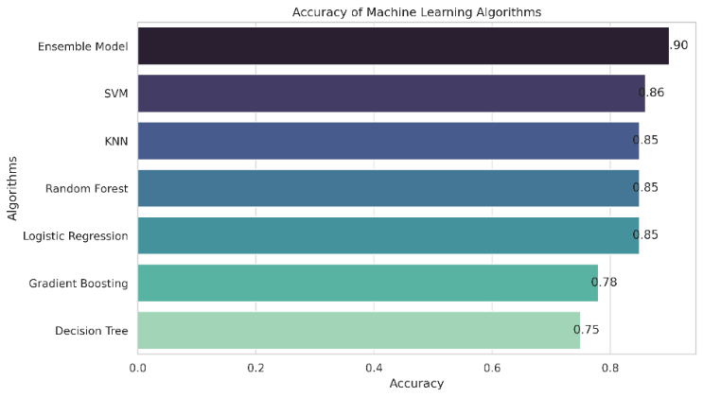

Figure 7 Accuracy given by different ML algorithms

In the context of medical diagnosis, accuracy is a broad measure of reliability. The ensemble model is 90% more accurate than other traditional machine learning approaches as given in figure 7. However, it's crucial to strike a balance between accuracy and recall to avoid emphasizing one while neglecting the other. The ensemble technique aims to increase overall accuracy by using each algorithm's unique strengths, resulting in an algorithm that is not only correct but also precisely calibrated and balanced. In simple terms, the ensemble technique combines the strengths of different algorithms to improve the accuracy of the model while ensuring that it is well-calibrated and balanced.

# Conclusion and Future Scope

The use of an ensemble machine learning technique has shown to be very successful in the prediction of heart disease. Compared to individual models, this technique provides higher accuracy and reliability by merging numerous algorithms, which efficiently interpret complicated patient data to support early diagnosis. It emphasizes the value of multidisciplinary teamwork and high-quality data, combining medical knowledge with cutting-edge analytics to get the best possible results.

For a more thorough risk assessment, future developments should concentrate on combining various data sources, such as genetic and lifestyle variables. Furthermore, it will be critical to prioritize personalized therapy and model explainability. Its efficacy and usefulness in diverse healthcare systems will be improved by adaptation to several global contexts and ongoing learning from fresh data, opening the door for more accurate and proactive heart disease treatment options.

##### References

1. Mohan, Senthilkumar, Chandrasegar Thirumalai and Gautam Srivastava. “Effective Heart Disease Prediction Using Hybrid Machine Learning Techniques.” *IEEE Access* 7 (2019): 81542-81554.
2. Chandrasekhar, Nadikatla and Samineni Peddakrishna. “Enhancing Heart Disease Prediction Accuracy through Machine Learning Techniques and Optimization.” *Processes* (2023): n. pag.
3. Bhatt, Chintan M., Parth Patel, Ta Ghetia and Pier Luigi Mazzeo. “Effective Heart Disease Prediction Using Machine Learning Techniques.” *Algorithms* 16 (2023): 88.
4. Sk, Khader Basha, Roja D, Sunkara Santhi Priya, Lavanya Dalavi, Sai Srinivas Vellela and Venkateswara Reddy B. “Coronary Heart Disease Prediction and Classification using Hybrid Machine Learning Algorithms.” *2023 International Conference on Innovative Data Communication Technologies and Application (ICIDCA)* (2023): 1-7.
5. Shaik, Mohammed Ali, Radhandi Sreeja, Safa Zainab, Panthangi Shiva Sowmya, Thipparthy Akshay and Sudireddy Sindhu. “Improving Accuracy of Heart Disease Prediction through Machine Learning Algorithms.” *2023 International Conference on Innovative Data Communication Technologies and Application (ICIDCA)* (2023): 41-46.
6. Singh, Akhand Pratap. “A REVIEW ON HEART DISEASE PREDICTION USING MACHINE LEARNING.” *International Research Journal of Modernization in Engineering Technology and Science* (2023): n. pag.
7. Sudha, V. K. and D.Maghesh Kumar. “Hybrid CNN and LSTM Network For Heart Disease Prediction.” *SN Computer Science* 4 (2023): 1-10.
8. El-Shafiey, Mohamed G., Ahmed M. Hagag, El-Sayed A. El-Dahshan and Manal A. Ismail. “A hybrid GA and PSO optimized approach for heart-disease prediction based on random forest.” *Multimedia Tools and Applications* 81 (2022): 18155 – 18179.
9. Bajaj, Madhvan, Priyanshu Rawat, Chandradeep Bhatt, Rahul Chauhan and Teekam Singh. “Heart Disease Prediction using Ensemble ML.” *2023 International Conference on Sustainable Computing and Data Communication Systems (ICSCDS)* (2023): 680-685.
10. Shah, Raghav & Pawar, Amruta & Kumar, Manni. (2024). Enhancing Machine Learning Model Using Explainable AI. 287-297. 10.1007/978-981-99-6906-7_25.
11. R. Bajaj, C. Chaudhary, H. Bhardwaj, L. Pawar, H. Gupta and D. Sharma, "A Robust Machine Learning Model for Prediction: The Electroencephalography," 2022 11th International Conference on System Modeling & Advancement in Research Trends (SMART), Moradabad, India, 2022, pp. 1270-1274, doi: 10.1109/SMART55829.2022.10047098.
12. D’Agostino, Ralph B., Ralph B. D’Agostino, Scott M. Grundy, Lisa M Sullivan, Lisa M Sullivan, Peter W. F. Wilson and Peter W.F. Wilson. “Validation of the Framingham coronary heart disease prediction scores: results of a multiple ethnic groups investigation.” *JAMA* 286 2 (2001): 180-7 .
13. Ali, Farman, Shaker El-Sappagh, S. M. Riazul Islam, Daehan Kwak, Amjad Ali, Muhammad Imran and Kyung Sup Kwak. “A smart healthcare monitoring system for heart disease prediction based on ensemble deep learning and feature fusion.” *Inf. Fusion* 63 (2020): 208-222.
14. Sekar, Jayachitra, Prasanth Aruchamy, Haleem Sulaima Lebbe Abdul, A. Mohammed and Shaik Khamuruddeen. “An efficient clinical support system for heart disease prediction using TANFIS classifier.” *Computational Intelligence* 38 (2021): 610 - 640.
15. Cn, Lakshmi, Bindhudhree M, Jaya Poojary, Manish C and Shylaja B. “Heart Disease Prediction Using Machine Learning Algorithms.” *2022 International Conference on Innovative Computing, Intelligent Communication and Smart Electrical Systems (ICSES)* (2022): 1-6.
16. H. Prasad, A. Singh, J. Thakur, C. Choudhary and N. Vyas, "Artificial Intelligence Based Fire and Smoke Detection and Security Control System," 2023 International Conference on Network, Multimedia and Information Technology (NMITCON), Bengaluru, India, 2023, pp. 01-06, doi: 10.1109/NMITCON58196.2023.10276198.
17. Bhajibhakare, Prof. M. M.. “Heart Disease Prediction using Machine Learning.” *International Journal for Research in Applied Science and Engineering Technology* (2019): n. pag.
18. Repaka, Anjan Nikhil, Sai Deepak Ravikanti and Ramya G Franklin. “Design And Implementing Heart Disease Prediction Using Naives Bayesian.” *2019 3rd International Conference on Trends in Electronics and Informatics (ICOEI)* (2019): 292-297.
19. A. Trivedi, E. K. Kaur, C. Choudhary, Kunal and P. Barnwal, "Should AI Technologies Replace the Human Jobs?," 2023 2nd International Conference for Innovation in Technology (INOCON), Bangalore, India, 2023, pp. 1-6, doi: 10.1109/INOCON57975.2023.10101202.
20. Raja, Munyaradzi, Mittal Anurag, Ch. Prachetan Reddy and Nageswararao Sirisala. “Machine Learning Based Heart Disease Prediction System.” *2021 International Conference on Computer Communication and Informatics (ICCCI)* (2021): 1-5.
21. Kumar, Manni & Nitasha, & Kaur, Manpreet & Monika, & Sharma, Nivedita. (2023). A Novel Zero-Shot Learning Approach for Multi-Classification of Orange Sooty Mold Disease Severity Levels. 1-5. 10.1109/ASIANCON58793.2023.10270619.
22. Valarmathi, R. S. and T. Sheela. “Heart disease prediction using hyper parameter optimization (HPO) tuning.” *Biomed. Signal Process. Control.* 70 (2021): 103033.
23. Kunal, B. Singh, E. K. Kaur and C. Choudhary, "A Machine Learning Model for Content-Based Image Retrieval," 2023 2nd International Conference for Innovation in Technology (INOCON), Bangalore, India, 2023, pp. 1-6, doi: 10.1109/INOCON57975.2023.10101215.
24. Anurag, Shreya Kalta, Jatin Thakur, Himanshu Bhardwaj and Yogesh Banyal. “Optimized Ensemble model for Heart Disease Prediction using Machine Learning.” *2023 3rd Asian Conference on Innovation in Technology (ASIANCON)* (2023): 1-5.